27.38: 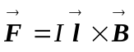
Between the poles of the magnet, the magnetic field points to the right. Using the fingertips of your right hand, rotate the current vector by 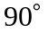 into the direction of the magnetic field vector. Your thumb points downward–which is the direction of the magnetic force.

